VICTORIA JUNIOR COLLEGE
Preliminary Examination
Higher 2

MATHEMATICS |  | 9740/02
PAPER 2
 |  | September 2012
 |  | 3 hours
Additional materials: | Answer paper  Graph paper  List of Formulae (MF15)

READ THESE INSTRUCTIONS FIRST

Write your name and CT group on all the work you hand in.
Write in dark blue or black pen on both sides of the paper.
You may use a soft pencil for any diagrams or graphs.
Do not use staples, paper clips, highlighters, glue or correction fluid.

Answer all the questions.
Give non-exact numerical answers correct to 3 significant figures, or 1 decimal place in the case of angles in degrees, unless a different level of accuracy is specified in the question.
You are expected to use a graphic calculator.
Unsupported answers from a graphic calculator are allowed unless a question specifically states otherwise.
Where unsupported answers from a graphic calculator are not allowed in a question, you are required to present the mathematical steps using mathematical notations and not calculator commands.
You are reminded of the need for clear presentation in your answers.

At the end of the examination, fasten all your work securely together.
The number of marks is given in brackets [ ] at the end of each question or part question.


This document consists of 5 printed pages
© VJC 2012 | VICTORIA JUNIOR COLLEGE | [Turn over

Section A: Pure Mathematics [40 marks]

- The complex number z satisfies 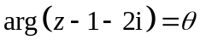, where is a fixed angle in the interval 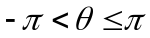.
- Give a geometrical description of the locus of the point P representing z. [1]
- Given that 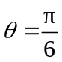, find the exact minimum value of 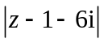. [3]
The complex number w satisfies 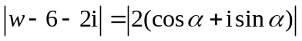, where 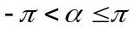. Sketch the locus of the point Q representing w. [2] [2]
- Find the range of values of such that the locus of  meets the locus of  more than once. [2]

- A sequence 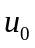, 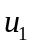, 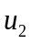, … is such that 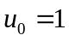 and
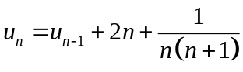 , for all 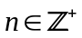.
- Express 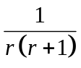 in partial fractions. Hence find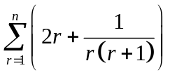 in terms of n. [4]
- By considering 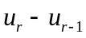 and using the result in part (i), show that
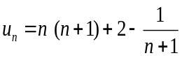 , where . [3]
- Using the result in part (i), find 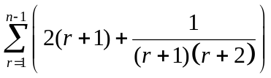 in terms of n. [3]

x
y
o

The above diagram shows the curve C with equation 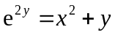 for x > 0.
- Make a copy of the diagram to include the portion of C for x < 0. [1]
- Show that 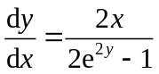. [2]
- Given that the line 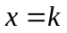is a tangent to C, find the possible exact values of k. [4]
- Find the equation of the tangent to C at the point 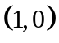and determine the x-coordinate of the point where this tangent meets C again. [4]
- The equations of three planes 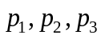 are
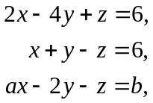
respectively, where a and b are constants. The planes 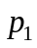and 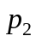meet in a line l .

- Find a vector equation of l . [2]
- Given that the system of equations
has an infinite number of solutions, find a and b. [4]

- Find, in the form 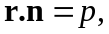 the equation of the plane which passes through the point (1, 1, 1) and is perpendicular to both and . [2]
- The plane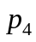 meets in a line m which passes through the point (3, 4, 1) and 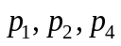have no point in common. Find the perpendicular distance between the lines l and m, giving your answer in an exact form. [3]

Section B: Statistics [60 marks]
- Over a period of one month, the increase in heights of orchid plants in a nursery has mean 1.34 cm and standard deviation 0.24 cm. Soothing music is introduced in the nursery and one month later, the increase in heights, x cm, is measured for a random sample of 55 orchid plants.

A test is carried out, at the 5% level of significance, to determine whether there has been a significant improvement in the increase in heights of the orchid plants.

(i) State appropriate hypotheses for the test and giving a reason, state if any assumption is
needed for the test to be valid. [2]
(ii) Find the set of values of for which the result of the test would be not to reject the
null hypothesis. [3]
(iii) Explain what is meant by ‘at the 5% level of significance’ in the context of this question. [1]

[Turn over
- (a) In a social club with 1000 members, the executive committee would like to survey the
members’ opinion on the activities organized by the club.
Give a possible reason why the committee would prefer to obtain a sample of opinions
instead of asking all the members. [1]

Explain how a systematic sample of size 100 might be obtained. [2]

Give one disadvantage of using systematic sampling in this context. [1]

(b) Ten friends at an event organized by a social club sit in a particular group of ten
adjacent seats. Determine the number of possible seating arrangements in which two
of them, Adam and Bernice, are separated by at least two people. [4]

- At a department store, shoppers who spend more than $1000 in a single receipt are entitled to a free gift. Each shopper is limited to at most one free gift for the entire promotion period. On average, 8 free gifts are claimed every week. State the distribution of the number of free gifts claimed in one week. [1]

- Find the least number of free gifts that must be kept in stock at the start of the week to be at least 95% sure that the free gifts will not run out during the week. [3]

- Due to budget constraint, the manager of the department store plans to limit the promotion period to m weeks such that the probability of more than 50 free gifts being claimed does not exceed 0.1. By using a suitable approximation, find the largest integer value of m. State an inequality satisfied by m for the approximation to be suitable. [5]

- During the Great Mega Sale, the waiting times, in minutes, for men and women, at their respective fitting rooms, have means 4.2 and 8.5, and standard deviations 1.6 and 2.2 respectively.

- The store manager wishes to ensure that the average waiting time of 50 randomly chosen women at the fitting room is more than k minutes occurs for at most 10% of the time. Find the least integer value of k. [4]

Given that the waiting times for both men and women are normally distributed,

- find the probability that the combined waiting time of 6 randomly chosen men differs from three times the waiting time of a randomly chosen woman by more than 4 minutes. State an assumption needed for your calculations. [5]

- find the probability that at least 3 women out of 4 women who are queuing at the fitting room will have to wait for more than 8.5 minutes. [2]
- The following table shows the mean temperature, x, in degree Celsius, from noon to 5pm over nine days in June and the number of ice cream cones, y, sold at a beach café.
x | 30.7 | 32.0 | 31.6 | 33.7 | 30.9 | 30.1 | 32.5 | 33.1 | 33.5
y | 70 | 102 | 90 | 180 | 75 | 69 | 121 | 146 | 173

- Draw a scatter diagram for these values, labeling the axes clearly. [2]
- Calculate the product moment correlation coefficient for the data and comment on its value. [2]
- The owner of the café employed a temporary staff to assist him on a day which had a mean temperature of 33.3ºC.

(a) | Use a suitable regression line to estimate the number of ice cream cones sold  on that day and comment on the reliability of this estimate. [3]
(b) | A check of the accounts showed that the temporary staff had reported a sale of 108 108 ice cream cones on that day. Using your answer to (a) above, explain the whether the owner has reasons to suspect that the temporary staff had been een dishonest in handling the profits for that day. [2]
- By calculating the value of the product moment correlation coefficient between ln y and x, explain which of 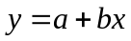 or 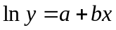 is the better model. Hence, obtain the best estimate of the percentage increase in the number of ice cream cones sold when the temperature increases by 2ºC, assuming that the model you have chosen remains valid. [4]

- Two fair n-sided dice, each with faces numbered ‘1’, ‘2’, … ‘n’, (where 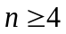) are tossed
in an experiment. The number that appears on each die is defined as the number on the face
that is in contact with the table. If the numbers that appear on the 2 dice are different, the
score is taken as the larger of the two numbers that appears and the experiment ends. If the
same number appears on both dice, the two dice are rolled again until two different numbers
are obtained.
A trial is defined as a toss of two dice.
(a) If 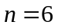,
(i) show that the probability of obtaining a score of 3 with two trials is 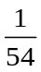, [3]
(ii) find the probability that the score is 3, [3]
(iii) find the probability that there are exactly four trials, given that the score is 3. [2]
(b) Show that the probability that the score is ‘3’ can be expressed as 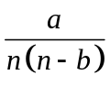, where a, b
are integers to be determined. [3]
Hence, find the greatest number of faces on each die such that the probability of
obtaining a score of 3 is at least 5%. [2]

